**Exploratory Data Analysis**

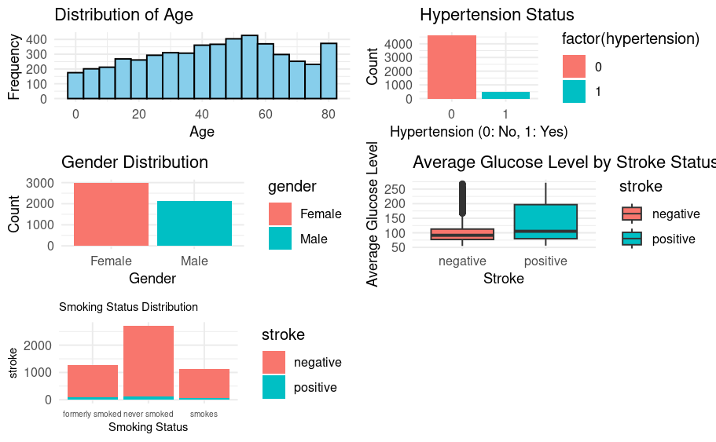

**Using Density plot to visualize distribution of prediction probabilities for Positive and Negative Class**

**Using Confusion Matrix to Test Model Performance:**

Truth

Prediction negative positive

negative 1211 67

positive 0 0

**Performance of the Model on Test Set:**

| **.metric** | **.estimator** | **.estimate** | **.config** |  |
| --- | --- | --- | --- | --- |
| accuracy | binary | 0.94757433 | Preprocessor1_Model1 |  |
| roc_auc | binary | 0.81771572 | Preprocessor1_Model1 |  |
| brier_class | binary | 0.04643307 | Preprocessor1_Model1 |  |

**User Interface of Prediction Model after Deployment**

